**BMA 499 Independent Study**



**Bradley University**

**12/8/15**

**Curtis Beiersdorf**

**Brandon Casey**

Table of Contents

**Burning Platform:** 3

**Project Scope:** 3

**Description of the Project:** 3

**Degree to Which Project Objective Were Met:** 4

**Future Considerations:** 5

**List of Achieved Deliverables:** 5

**User Documentation:** 6

Logging into DeltaTime: 6

Creating a New User: 6

Listing All Current Users: 8

Creating a New Project: 9

Creating a Project Report: 9

Creating a Resource Report: 9

Changing Your User Password: 9

**Technical Documentation:** 9

**Glossary:** 9

## **Burning Platform:**

With this specific project, the students (Curtis Beiersdorf and Brandon Casey) were identified as the customers. Both students have elective credits that must be met. Of the courses that were available, there were time conflicts with other classes and/or work obligations. Originally, the students were going to do a continuation of their MIS 478 senior design project, however due to various constraints, out of their control, further project development was scrapped. This left both students to come up with a business related application to develop.

After deliberation by the students, they returned with a proposal for a time tracking web application that would be developed in .NET using C# and Visual Studio. This was something that they believed would help them to take a deeper dive into application/server/database communication and meet a December 8th 2015 deadline. Details of the project are defined in the Project Scope and Description of the Project sections.

## **Project Scope:**

The students are expected to be able to deliver a fully functioning time reporting application using .NET and C#. The end goal is to have this hosted by GoDaddy via www.cjxsolutions.com, a website already owned by Curtis Beiersdorf. It is expected that this could also be expanded to allow for students to enter project time information that is required in some classes. This project is to be completed by 12/8/15.

## **Description of the Project:**

The overall goal of the project is to allow users to enter the amount of time that they spent on a given project. The project is being geared towards a Web application, as this allows for easier implementation across various devices. The application should include, however not just limited to the following:

* Allow user creation
  + Based on a username and password.
  + Other information such as email address etc. can also be added.
  + Also allow a method for deleting users.
* Offer login authentication using strong password practices.
  + Ability to change passwords.
* Allow users to be assigned to a specific role.
* Allow project creation.
  + Ability to add smaller segments to an overall project.
* Ability to edit already created projects.
* Ability to run reports on projects and resources tied to a specific project.
* Ability to add time spent on a project.
  + Includes edit capabilities
* Several misc. tasks that will be required to make all functions of the application work.

Benefits of this project have the potential to directly affect both Bradley’s faculty and students. Several course group projects, where a real client is involved, students are required to fill out paper time sheets to record activities that they completed towards to project goal. These are typically either submitted via Sakai, e-mail to the instructor, or turned in during a class period. Not only does this process waste paper, it also forces both the instructors and students to have to keep track of a single paper for upwards of a month before turning it in.

With the development of this time tracking Web application, paper copies could be eliminated. Instructors would be able to create projects and assign students to different segments of the project and ask them to report their time. This also allows for students to submit time immediately upon the completion of a task, as the time tracker application will be able to keep track of each and every entry a user creates.

Curtis and Brandon have obtained all approvals from Dr. McGowan regarding the development of this Web application. As previously mentioned, they will develop this in .NET using C# as well as create a .MDF database that will be attached to the project. This database will store all of the information regarding the project. Specific views along with stored procedures will also be created on the database to make SQL calls easier to work up and update down the road.

## **Degree to Which Project Objective Were Met:**

The main objectives were completed on time by Curtis and Brandon. A time tracking Web application (now known as DeltaTime) was developed and is able to do all of the things that are described in the Project Scope section. While development occurred, opportunities for further enhancement have been called out in the Future Considerations section of this report. These enhancements were not included in the original scope of the project due to fear of not being able to complete the already approved project scope goals by the December 8th, 2015 deadline.

There have been some ongoing issues with GoDaddy and getting the application to fully work on GoDaddy’s servers. The project works as expected on a local machine, however for unknown reasons when the Web application is published to GoDaddy, unknown errors occur. We have been working with GoDaddy customer support to try to get this issue resolved, however their customer support has been subpar.

All of the code, user documentation, technical documentation, and any other files related to this project have been turned over to Dr. McGowan.

## **Future Considerations:**

The original scope required that a Web application along with a database for storing DeltaTime’s many features. There is room to expand upon this base application and some of the things to consider are listed below:

* Expand DeltaTime to be used as an application for a specific device
  + Android
  + iOS
  + Windows Phone
* Create additional roles with expanded permissions
  + This would create additional functionality and security for specific projects that may require the added roles.
* Expand on the user and resource reporting functions
  + Create the ability to download a .pdf version of the report after it is created
  + Add the ability to create custom reports based on specific user needs.
* Server Enhancements
  + Since this was developed for Bradley University needs, skip online hosting and have the application hosted on Bradley’s Intranet.
  + Continue to research to see why the application cannot be hosted on GoDaddy as originally expected.
* Create new ways for users to log in
  + Google +
  + Facebook
* Create an e-mail interface
  + This could allow for 2 way authentication when a user account is created.
  + Allows for the ability to use a more secure forgot password feature.
  + Allow for project reports to be e-mailed to interested parties.

## **List of Achieved Deliverables:**

* Created a working time tracking solution frontend
* Advised on alternate hosting solutions
  + Current hosting service is not working as expected.
* Developed an ERD based on the flow of the system
* Implemented a DBMS
  + A Timetracker.mdf file that is included within the project.
  + This can be changed via Visual Studio 20** or imported into SQL Server 20**.
* Added security for user authentication
  + User passwords are encrypted on the database.
  + Passwords must include a number and special character.
* Created both user and technical documentation that will allow other users to manage the application code and database as needed.
* Created stored procedures on the database to make the code within the actual application more efficient.
* Set up an Administrators account to allow for a person to set up an instance of the application for the first time.
  + Username = **Admin**
  + Password = **password@2** (case sensitive)

## **User Documentation:**

## Logging into DeltaTime:

When logging into the DeltaTime application you will be prompted to enter your Username and Password. If this is the first time that you are launching the application, you will have to log in using the default administrator username and password. The default username is Admin and the default password is password@2. Both of the username and password is case sensitive. This will be important to remember later on when creating new users.

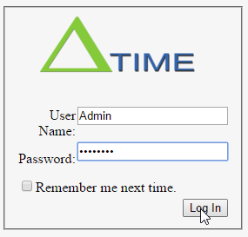

If you already have a username and password set up for your account, then put them in the username and password fields respectively. Once you have done this, then click the Log in button to gain access to the application. If you leave any field blank or type anything incorrectly, you will be prompted to correct your mistake. Additional information regarding some of the errors and the messages that you may run across will be covered in greater detail in the Technical Documentation section.

Once you have successfully logged in, you will be redirected to the application’s project page. This is where your current projects are displayed.

## Creating a New User:

Only Project Managers and Project Administrators have the ability to create new user accounts. If your user meets the Project Manager or Project Administrator role requirement and there is a need to create a new user. This can be done by doing the following:

Click on the Create a New User link on the left side of the page.

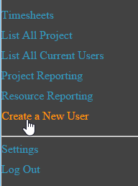

After clicking on the Create a New User link, you will be directed to the user creation page.

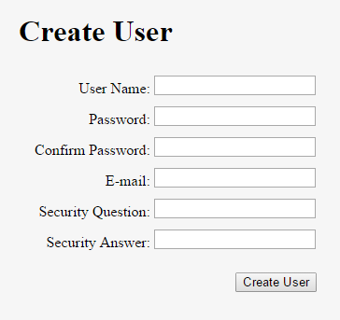

Here you need to fill out each field and press Create User when finished. All fields are required. If any field is empty wen clicking the Create User button, the application will prompt you to correct the errors. Passwords must also be at least 7 characters long and include at least 1 number and one special character.

After you have filled out each field click the Create User field. If each field meets the requirements laid forth by the application, then you will see the screenshot below.

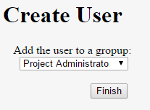

From here you will select the role that the user will be assigned to. There are currently 3 different roles at the time of documentation creation. Those roles are Project Administrator, Project Manager, and Project Consultant. Each have certain areas of the website that can be accessed based on the role that they have.

As you can see from the next screenshot, clicking on the downward pointing arrow will bring up a drop down box with the different roles described above.

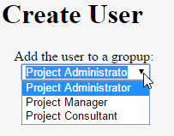

Once you have selected the role that you want to assign to the user, then click the Finish button. You should be prompted with the next screen that will confirm that the user was created. From here click the Continue button.

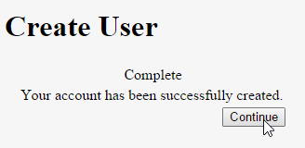

If there are projects created, then you will be directed to the timesheet page that will allow you to record project hours. If no projects have been created yet, then the project page will display a message stating that no projects have been assigned to you. More on this in the Creating a New Project section.

## Listing All Current Users:

The idea behind this page is to display a listing of all the current user accounts in the system. This does not take into account any projects that they are associated with due to that function being contained within the Project Reporting function.

Click on the List All Current Users link on the left side of the application in order to view all of the current user accounts:

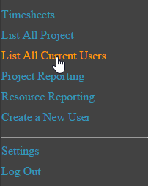

After clicking on the link in the above screenshot, you will be redirected to the All Current Users page. The screenshot below displays test data for users that were created for this documentation and application testing.

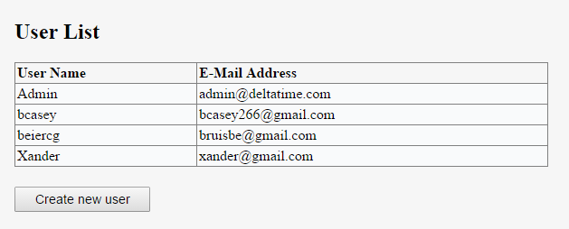

If a user does not show up in this list, then they do not have an account within the application.

It is also worth noting that you can create a new user from this screen by clicking the Create New User button below the table. Follow the instructions contained within the Create a New User section for instructions on how to create a new user.

## Creating a New Project:

In order to create a new project, you first have to click on the List All Projects link on the left side of the application.

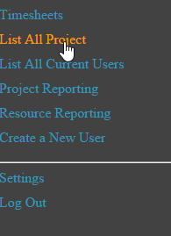

After clicking on the List All Projects link, you will be presented with a list of all the projects that have been created within the application. If there are not any projects that have been created, then you will see a message stating that there are no projects to display. The projects below have been created for application testing and this documentation.

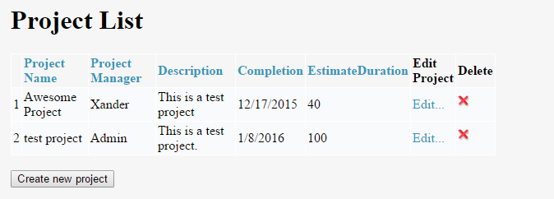

If there is a project that you want to edit, then it can be done by clicking on the Edit Project link. More on that will be discussed within the Technical Documentation.

Whether you have projects displayed, or the message that states there are not any projects to display, there will be a button below that says Create New Project. As you suspect, clicking on this button will transfer you to the Create a New Project page.

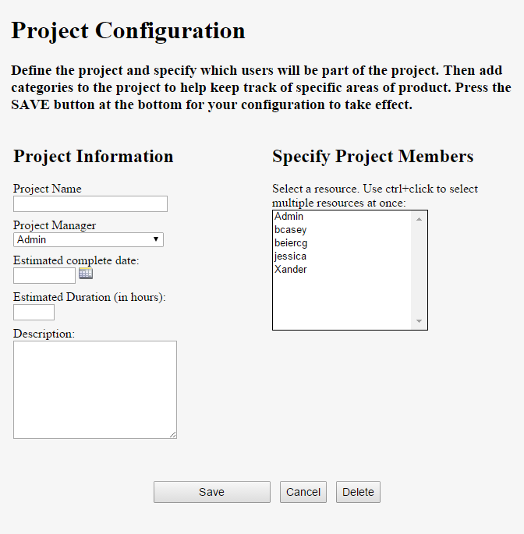

This screenshot above will give you an idea of all the different fields that have to be filled out. It is worth noting that the box under Specify Project Members will look different depending on what users you have created within you DeltaTime instance. The users shown above have been created for application testing and creation of this documentation.

Enter the Name of the Project in the Project Name field. The only restriction on the title is a 255 character limit.

Use the dropdown menu under Project Manager to select the project manager for the project. You need to keep in mind that anyone with the role of a Project Consultant cannot be selected as a Project Manager, therefore they will not show up in the drop down list.

You can enter a date in the Estimated Complete Date field, or you can click on the  icon next to the field that will bring up a pop-up menu with a calendar to select a date. Once you have the date selected as your estimated project completion date, then click ok and it will populate the field for you automatically.

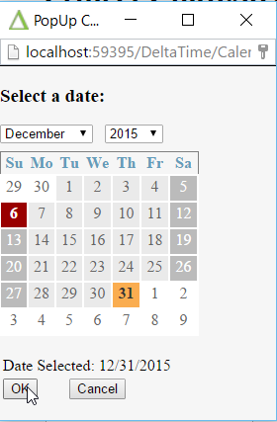

In the Estimated Duration (in hours) field, you will want to enter the number of hours that you have budgeted for the entire project across all resources.

The Description field is a free form text field that will allow you to describe the project. There is a 255-character limit for the description of the project.

All of the people that can be assigned to a project are listed under the Specify Project Members window. You can select just 1 person, or multiple people by using ctrl-click to select multiple resources at once. Additional people can be added or removed at a later time if needed.

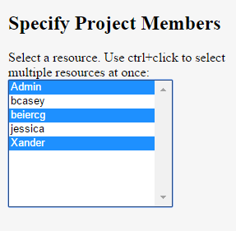

After you have added everything that you desire for this specific project, click the Save button at the bottom of the screen to Save the project with the information that you have entered.

If you are editing a current project, you can Delete the project by clicking the Delete button, or you can click Cancel to cancel any edits that you have made on the page. If you click the Cancel button it will direct, you back to the Project List page.

By clicking the Delete button, you will be prompted with the following message to ensure that you actually want to delete the project.

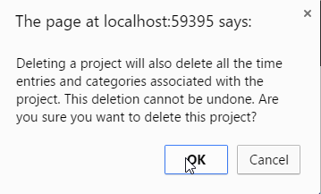

Assuming you have clicked the Save button and the project has been created, an option menu will be displayed to the side of the project that you just created. All of these options are optional and not required for project creation.

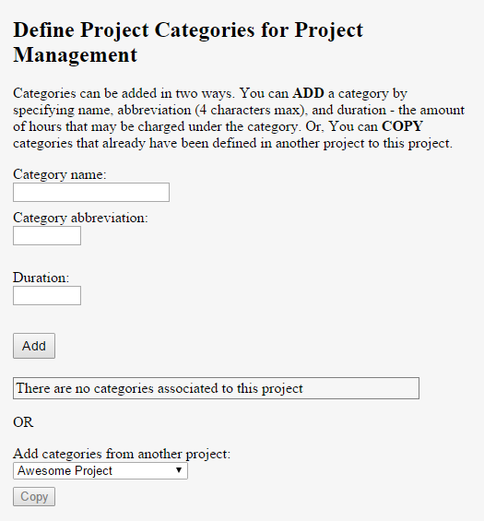

This section allows you to add categories for your project. This was added due to the fact that in most cases a project is being completed by multiple divisions or areas of expertise. By creating categories allows for time reporting to be placed into buckets to give an organization a better understanding on what departments are being impacted the most by certain projects.

Following the directions in the screenshot will allow you to create a category. You can have as many categories as you would like, however it is recommended that the duration (in hours) that you place for each category and the duration of all the categories does not exceed the Estimated Duration for the overall project.

It is also worth noting that if you have other projects created you can copy over categories from that project so you don’t have to manually enter them again, since it is likely that some of the same groups may be working on both projects.

Once you have created the categories that you have decided to create, click the Save button again at the bottom of the screen and then click on the List All Projects link again to see the newly created project.

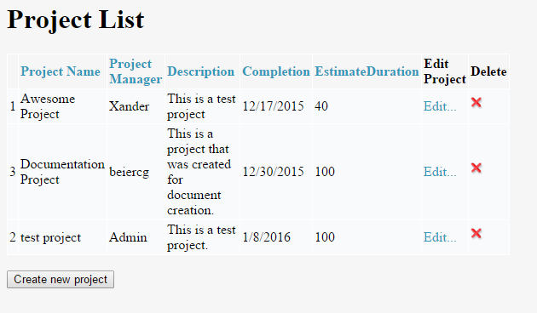

If you need to edit a specific project, then click the Edit link next to the name and it will bring up the project creation screen that will allow you make any edits that you need.

## Creating a Project Report:

## Creating a Resource Report:

## **Technical Documentation:**

## **Glossary:**